Rohtang Pass

Paragliding, mountain, and honeymoon

Rohtang Pass, is a high mountain pass on the eastern Pir Panjal Range of the Himalayas around 51 km from Manali. It connects the Kullu Valley with the Lahaul and Spiti Valleys of Himachal Pradesh

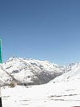

Solang Valley

Paragliding, adventure, and extreme sport

Solang Nala derives its name from combination of words Solang and Nullah. It is a side valley at the top of the Kullu Valley in Himachal Pradesh, India 14 km northwest of the resort town Manali

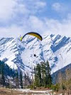

Hidimba Devi Temple

4.6

(1,831)

Historic wooden Hindu temple in a forest

This 1500s Hindu temple built of wood in a cedar forest has intricate carvings & a shrine.

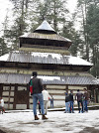

Bhrigu Lake

Lake and camping

Bhrigu Lake or Brighu Lake is a lake located at an elevation of around 4,300 metres in Kullu district, Himachal Pradesh, India. It is located to the east of Rohtang Pass and is around 6 kilometres

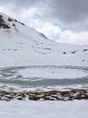

Great Himalayan National Park

4.4

(149)

National park in a mountainous setting

Sprawling national park with diverse plant & animal species in a scenic, high-altitude setting.

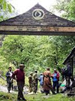

Manali Sanctuary

4.3

(356)

Wildlife refuge, wildlife, and park

The Manali Sanctuary is a wildlife sanctuary in Himachal Pradesh in northern India. The sanctuary starts about 2 km from Manali. It is the catchment of Manalsu khad. A path from Manali log huts

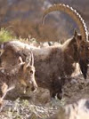

Pandoh Dam

Reservoir, river, rafting, and lake

The Pandoh Dam is an embankment dam on the Beas River in Mandi district of Himachal Pradesh, India. Under the Beas Project, the dam was completed in 1977 and its primary purpose is hydroelectric

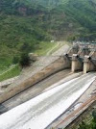

Museum of Himachal Culture & Folk Art

3.9

(147)

Museum exhibiting regional artifacts

Small museum showcasing Himachal heritage with various traditional objects & building models.

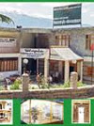

Manu Temple

4.4

(266)

Old Hindu temple in scenic surrounds

This historical Hindu temple in a serene setting backdropped by mountains is accessible by foot.

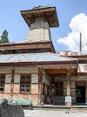

Tibetan Monastery

[**Website**](https://www.trawell.in/himachal/manali/tibetan-monasteries-manali)

[**Directions**](https://www.google.co.in/maps/dir/''/manali/data=!4m5!4m4!1m0!1m2!1m1!1s0x3904880713cb5fff:0x31d9e446049660da?sa=X&ved=2ahUKEwixt4uI6qnaAhXKtY8KHTruDZAQ9RcwAHoECAAQCQ)

4.3[103 Google reviews](javascript:void(0))

Monastery in Manali, India

[**Address**](https://www.google.co.in/search?safe=strict&dcr=0&site=async/lcl_akp&q=tibetan+monastery+address&stick=H4sIAAAAAAAAAOPgE-LVT9c3NEyrMM9NNitJ15LNTrbSz8lPTizJzM-DM6wSU1KKUouLAYq_u7gwAAAA&sa=X&ved=2ahUKEwixt4uI6qnaAhXKtY8KHTruDZAQ6BMwBHoECAAQFQ)**:**Manali, Himachal Pradesh 175131

[Suggest an edit](javascript:void(0)) · [Own this business?](https://www.google.com/local/add/choice?latlng=3592153167180488922&hl=en&getstarted&utm_medium=et&utm_source=gmb&utm_campaign=in-en-et-ip-z-gmb-s-z-l~skp%7Cclaimbz%7Cu&gmbsrc=in-en-et-ip-z-gmb-s-z-l~skp%7Cclaimbz%7Cu&ppsrc=GMBSI)

Add missing information

[Add phone number](javascript:void(0))

Questions & answers

[**Ask a question**](https://www.google.co.in/destination/map/topsights?q=manali&safe=strict&sa=X&dcr=0&biw=1137&bih=681&site=search&output=search&dest_mid=/m/046x4x&ved=0ahUKEwj3otXI6KnaAhXBN48KHcXpDG8Q69EBCD0oAjAB)

**Q:** Are rooms available here for stay in monastry?

**A:** No, but nearby hotels are available. This may help you.

(5 more answers)

## Manali Club House

3.8

(3,031)

Mountain hangout with games & an eatery

Elevated recreational center featuring a restaurant, indoor games & outdoor activities for all ages.

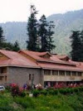

1. Hotel Iceland

4.2

(192)

Mountain lodge near outdoor recreation

This relaxed lodge with mountain-view rooms offers nearby skiing, river rafting & rock climbing.

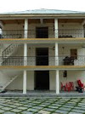

Solang Ropeway & Ski Center

4.3

(159)

Recreational mountain for winter skiing

Winter mountain resort offering ski slopes, paragliding, ATV rides & snowmobiling trails.

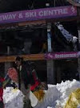

Siyali Mahadev Temple

4.6

(56)

Historic Hindu temple made of wood

Historic Hindu temple dedicated to Lord Shiva & featuring unique wooden architecture.

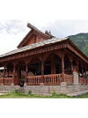

Himvalley Amusement & Cultural Park Manali

3.7

(153)

Playful rides & scenic mountain views

Amusement park backdropped by mountains offering simple rides, cultural performances & a food court.

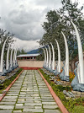

Van Vihar

4.0

(1,620)

Leafy national park with animal habitats

National park in a tree-filled riverfront setting with a variety of animals in natural habitats.

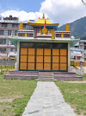

Jogini Falls

4.5

(530)

Scenic, sacred waterfall with shrines

This picturesque waterfall in a remote, tranquil setting has shrines below it & is sacred to locals.

